Has anyone use "grepwin" before? (Please share your experiences, I like, I think Microsoft should make it part of its OS.)

One can find the download from the many sources. This is my preferred download link: <http://stefanstools.sourceforge.net/grepWin.html>

Note:

* This tool operates on the Window OS only.
* Mac Users, please internet search “is there grepWin for the MacOS” and explore similar tools.

This is an example of the download page:

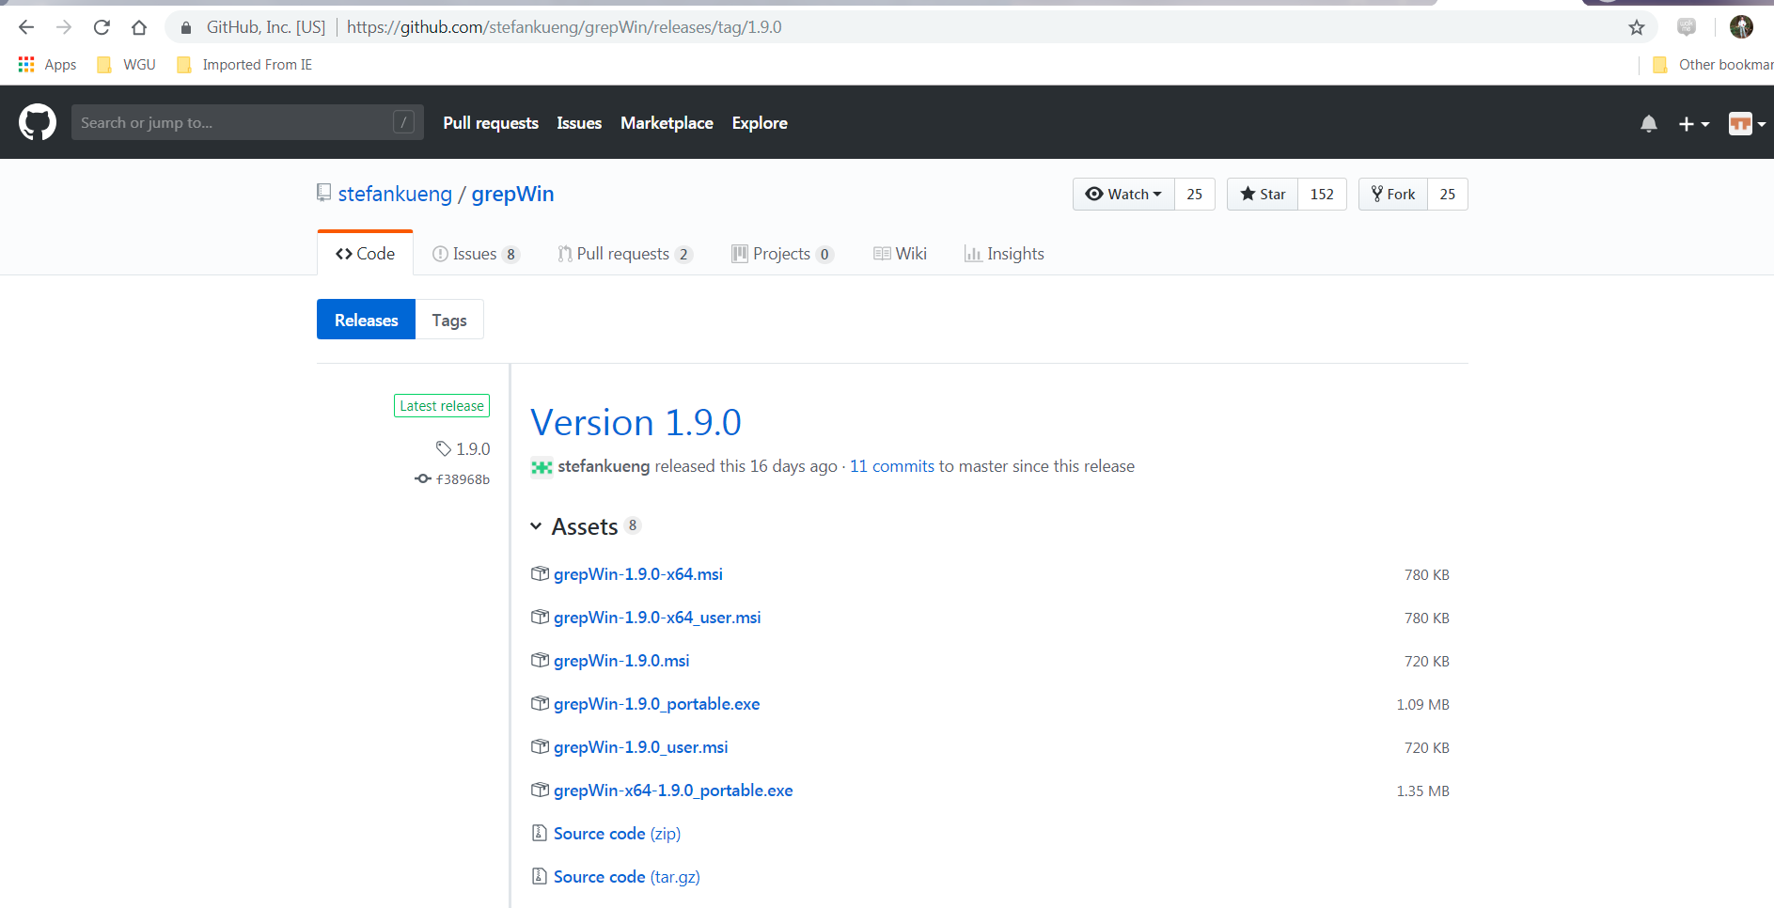

Launch “grepwin” and search for the text pattern “&.*[\W\D\S].*&” as shown below (note highlighted subtleties)

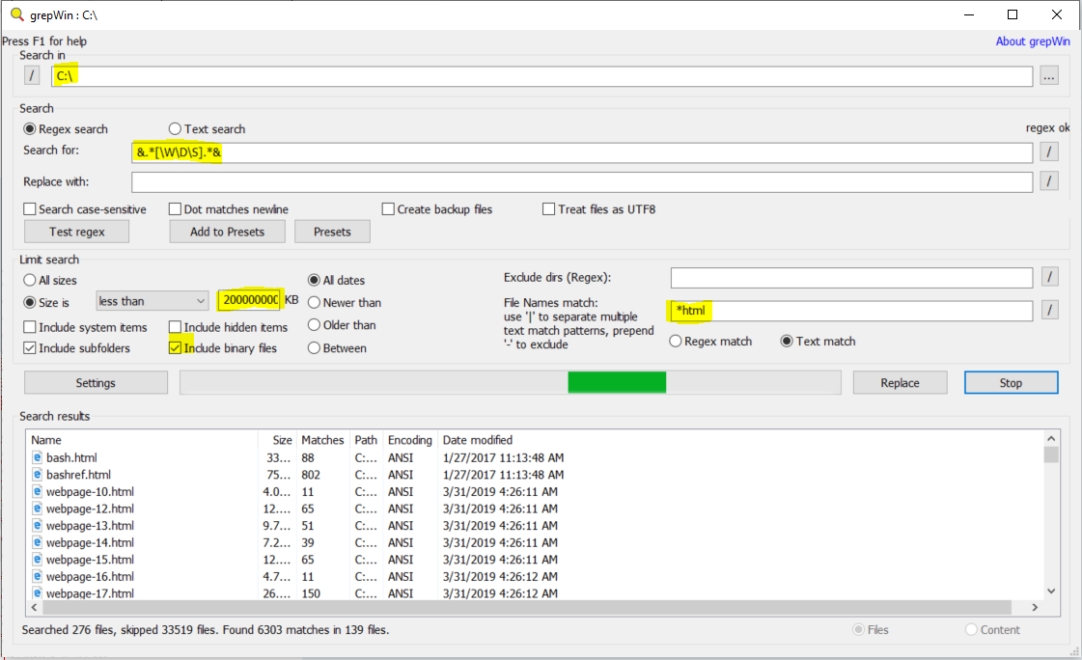

Monitor your CPU resource usage by “grepwin”. An example is shown below:

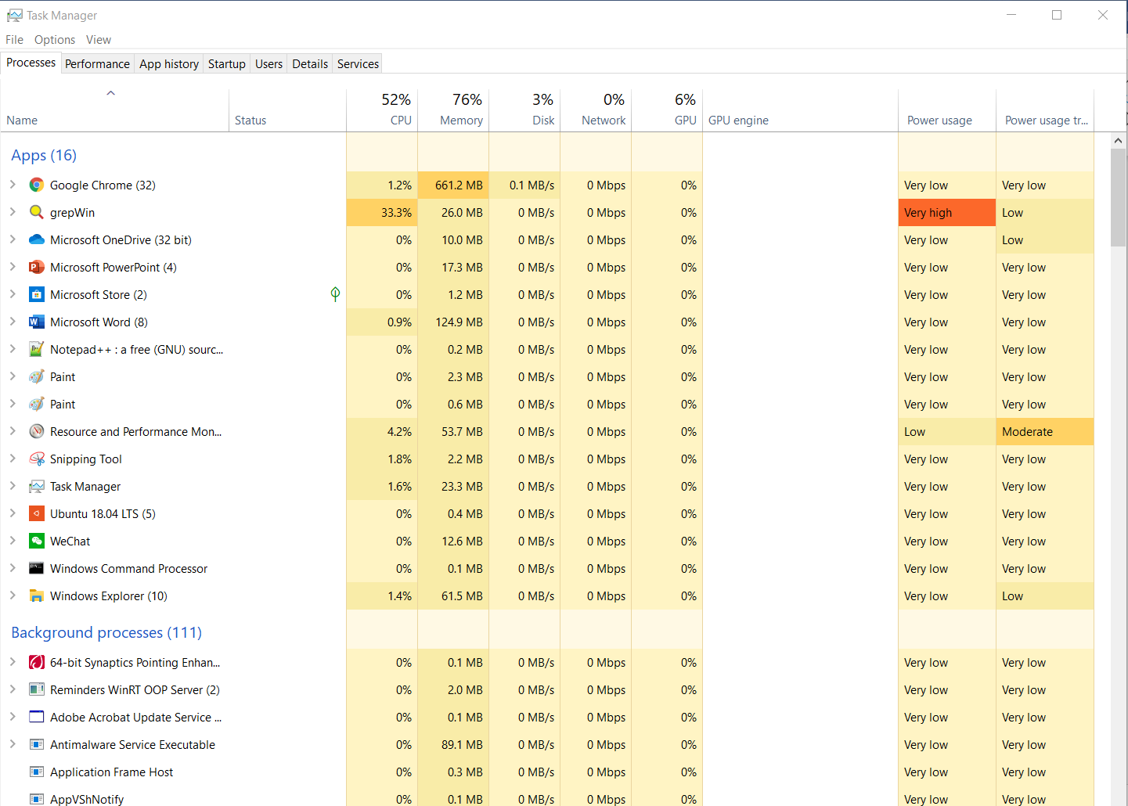

Questions:

1. How do you conduct text pattern searching on your PC?

One the file search tool, like grepWin, use regular expression search on the specified path. In addition, there is Windows OS File Explorer.

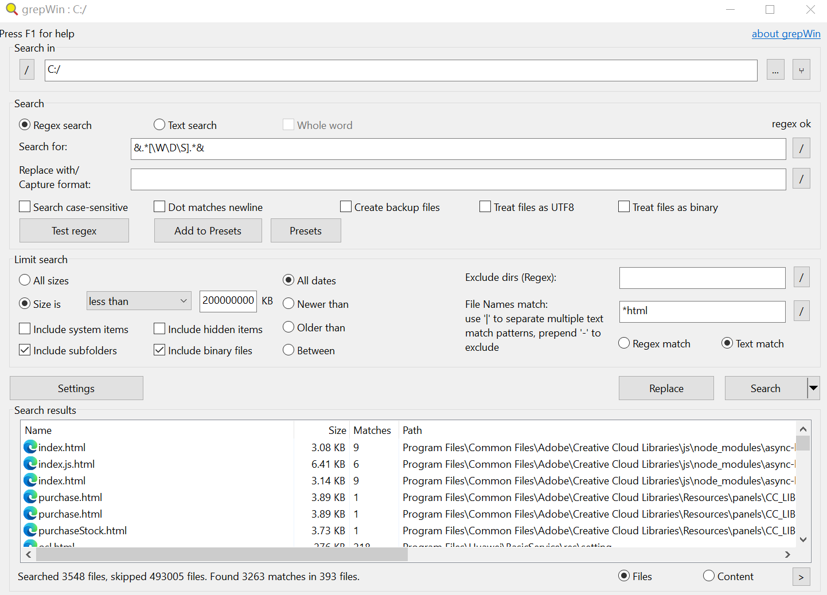

1. Why this “simple” search operations take so long?

Because the path is not accurate, the C disk is very large, there are too many files, it takes a long time to operate, and there are many web files that match with the regular expression.

1. What computing resources are being heavily utilized by “grepWin”? (CPU, Memory, IO, Storage, Networks etc.)

CPU resources

Memory resources

Hard disk resources

Parallel time resources

1. Try another “search pattern” (e.g. [A-Z]\w+) of your utmost interest and make your observations. *Note: You need to “Regex search”, not “Text Search”. If you have program source code, practice grepWin by searching for a code entry.*

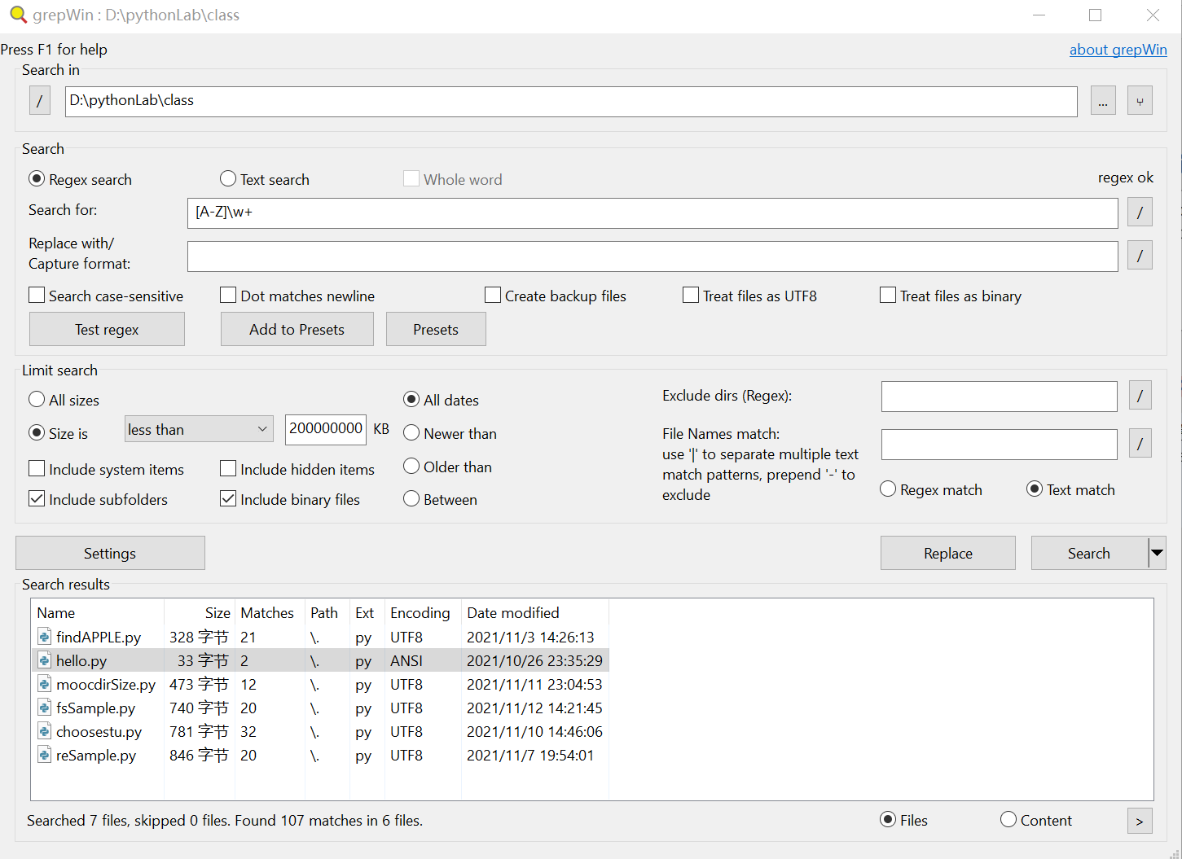

1. Can you recommend another tool that supports Regular Expression and operates on the Window OS?

Microsoft Word

Visual Studio/ Visual Studio Code

EditPlus

**Submission:**

Please submit to online. If that fails, email your results to: bangpanliang@gmail.com

The subject of the email should be:

[Your StudentID, Assignment Name]

Example of two different search results between Windows OS File Explorer and “grepWin”

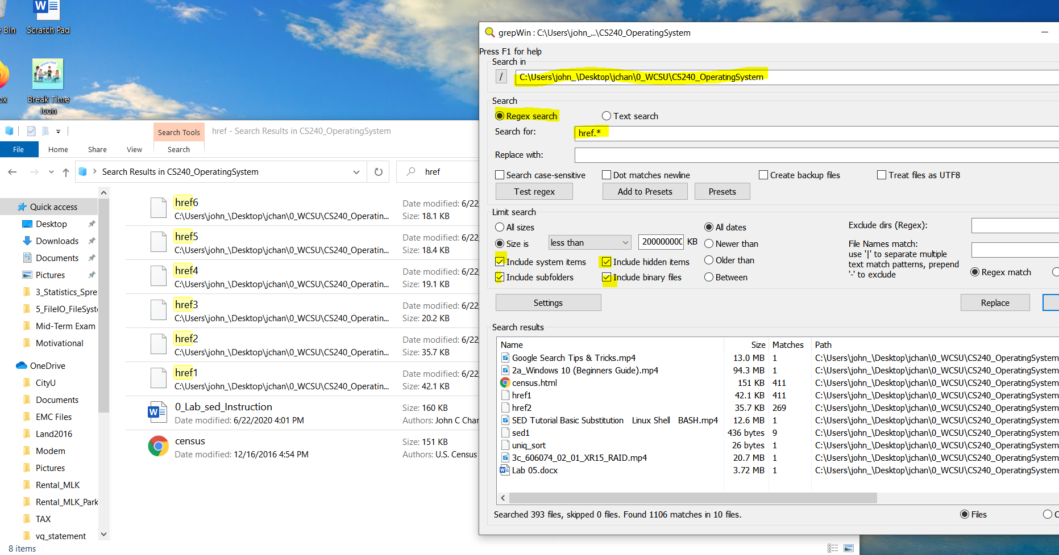

Example of RegExr search on the Window OS using “grepWin”:

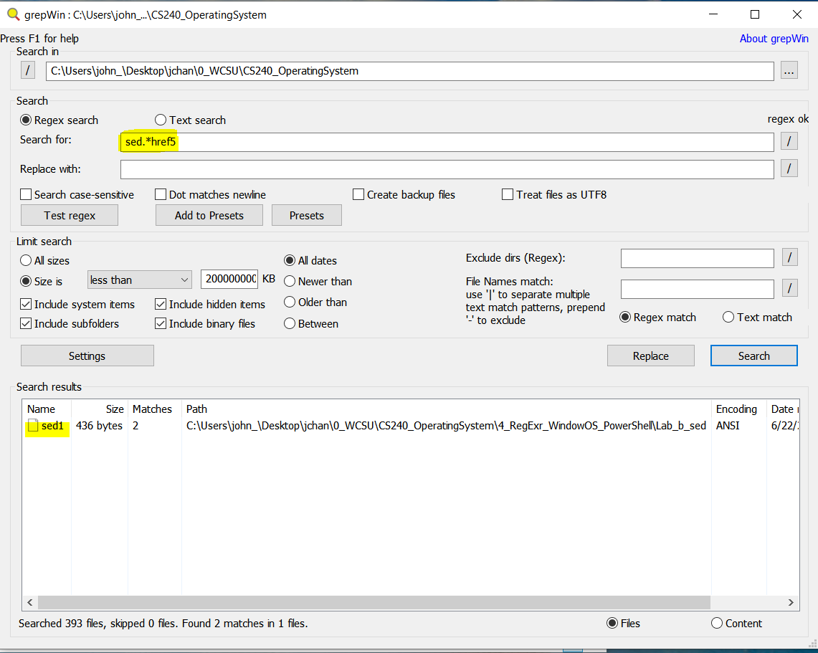

Overall Picture:

